

**Phi Beta Sigma Fraternity, Inc.**

**Eastern Region**

**Gamma Lambda Sigma Chapter**

P.O. Box 7143

Pittsburgh, PA 15213  
GLS1914@gmail.com

**President**

Aaron Cook

[alcst20@gmail.com](mailto:alcst20@gmail.com)

**1st Vice-President**

Daniel Williams

[zazu1914@gmail.com](mailto:zazu1914@gmail.com)

**2nd Vice-President**

Corey Fraction

[fraction.corey@gmail.com](mailto:fraction.corey@gmail.com)

**Secretary**

Chauncey Alexander

[ctast6@mail.rmu.edu](mailto:ctast6@mail.rmu.edu)

**Treasurer**

Terrance Johnson

[hitoridepbs@gmail.com](mailto:hitoridepbs@gmail.com)

# 2015 ANNUAL CHAPTER REPORT

# Scholarship and Academic Achievement

## Scholarship

### The Alumni Chapter invited a Soror who works at UPMC in recruitment to come speak at one of our chapter meetings on the types of internships and transitional programs that their job offers and invited all of the undergraduate chapters to attend as well as sent copies of the presentation and contact information to those chapters who were unable to attend. This presentation was very helpful to some Brothers who were present and has gotten several undergrads engaging in discussions with UPMC on how to make their grades and resumes more appealing for those Brother’s looking to enter that field.

The Alumni Chapter is also actively engaging in dialog with the Undergraduate Chapters we sponsor to ensure that they are both improving their school work and balancing the commitments they made to Sigma accordingly, not sacrificing their academics to do the work of Sigma.

## Academic Achievement

### In the spring semester of 2015, chapter members Terrell Bobb and Alvin Abston graduated from Carnegie Mellon University and Duquesne University respectively, both receiving their Bachelor’s Degree.

# Program Implementation and Reporting

A. Reports

|  |
| --- |
| Program Implementation Assessment |

|  |  |
| --- | --- |
| **Program Area of Focus \*** | Social Action |
| **Chapter Type \*** | Alumni |
| **Region \*** | Eastern |
| **Sponsoring Chapter Name\*** | Gamma Lambda Sigma |
| **Name \*** | Daniel Williams |
| **Chapter Position \*** | 1st Vice-President |
| **Email \*** | [zazu1914@gmail.com](mailto:zazu1914@gmail.com) |
| **Phone Number \*** | [(215) 430-3603](tel:%28215%29%20430-3603) |
| **Date of Event \*** | Saturday, November 7, 2015 |
| **Number of Service Hours of Event \*** | 20 |
| **Venue/ Activity Location \*** | 2603 East Carson St Pittsburgh PA, 15203 |
| **Description of Activity/Program \*** | Sigmas Against Domestic Abuse - Painting With A Twist |
| **What were the intended goals of the program/activity? \*** | To raise both awareness about Domestic Violence and avenues for help as well as serve as a fundraiser for the Crisis Center North Branch of Domestic Abuse Help in Pittsburgh. |
| **How many people did you or your chapter specifically reach, serve, or provide information or educational materials? \*** | 30 |
| **How many members of your chapter participated in activity? \*** | 10 |
| **National Partnership Fundraising Event: \*** | No |
| **Was the event a Sigma Wellness- Health event? \*** | No |
| **Was the event a Sigma Wellness-Bigger and Better Business event? \*** | No |
| **Was the event a Sigma Wellness-Education event?\*** | No |
| **Did your Chapter event require or use an outside moderator(s) or other professional speaker(s)? \*** | Yes |
| **How well did the moderator(s) or professional speaker(s) do? \*** | Good |
| **Since your chapter's last reporting, have you dispersed any scholarship funds? \*** | No |
| **In the past year, how much money would you say your chapter has dispersed in scholarship or education related activities? \*** | $0 |
| **Type of Media Coverage** | Internet |
| **Were Pictures Taken of Event?** | Yes |
| **Was Video Taken of Event?\*** | No |
| **Rate the Event's Success based on pre-determined goals \*** | Good |
| **Would you recommend that chapters implement this program in the future?\***   |  | | --- | | Program Implementation Assessment |  |  |  | | --- | --- | | **Program Area of Focus \*** | Social Action | | **Chapter Type \*** | Alumni | | **Region \*** | Eastern | | **Sponsoring Chapter Name\*** | Gamma Lambda Sigma | | **Name \*** | Daniel Williams | | **Chapter Position \*** | 1st Vice President | | **Email \*** | [Zazu1914@gmail.com](mailto:Zazu1914@gmail.com) | | **Phone Number \*** | [(215) 430-3603](tel:%28215%29%20430-3603) | | **Date of Event \*** | Saturday, August 15, 2015 | | **Number of Service Hours of Event \*** | 42 | | **Venue/ Activity Location \*** | Fairview Park | | **Description of Activity/Program \*** | Community Day | | **What were the intended goals of the program/activity? \*** | To set up and help run rides, and events at a local community day that is like a town fair or carnival for youth of a local church | | **How many people did you or your chapter specifically reach, serve, or provide information or educational materials? \*** | 150 | | **How many members of your chapter participated in activity? \*** | 7 | | **National Partnership Fundraising Event: \*** | No | | **Was the event a Sigma Wellness- Health event? \*** | No | | **Was the event a Sigma Wellness-Bigger and Better Business event? \*** | No | | **Was the event a Sigma Wellness-Education event?\*** | No | | **Did your Chapter event require or use an outside moderator(s) or other professional speaker(s)? \*** | Yes | | **How well did the moderator(s) or professional speaker(s) do? \*** | Excellent | | **Since your chapter's last reporting, have you dispersed any scholarship funds? \*** | No | | **In the past year, how much money would you say your chapter has dispersed in scholarship or education related activities? \*** | $0 | | **Type of Media Coverage** | Newspaper | | **Were Pictures Taken of Event?** | Yes | | **Was Video Taken of Event?\*** | Yes | | **Rate the Event's Success based on pre-determined goals \*** | Excellent | | **Would you recommend that chapters implement this program in the future?\*** | Strongly Recommend |  |  | | --- | | Program Implementation Assessment |  |  |  | | --- | --- | | **Program Area of Focus \*** | Social Action | | **Chapter Type \*** | Alumni | | **Region \*** | Eastern | | **Sponsoring Chapter Name\*** | Gamma Lambda Sigma | | **Name \*** | Daniel Williams | | **Chapter Position \*** | 1st Vice-President | | **Email \*** | [zazu1914@gmail.com](mailto:zazu1914@gmail.com) | | **Phone Number \*** | [(215) 430-3603](tel:%28215%29%20430-3603) | | **Date of Event \*** | Saturday, January 24, 2015 | | **Number of Service Hours of Event \*** | 70 | | **Venue/ Activity Location \*** | 335 Dorothy Dr., Penn Hills, PA 15235 | | **Description of Activity/Program \*** | Habitat for Humanity | | **What were the intended goals of the program/activity? \*** | To Help Build a house for those who are less fortunate and going thru though times. | | **How many people did you or your chapter specifically reach, serve, or provide information or educational materials? \*** | 4 | | **How many members of your chapter participated in activity? \*** | 10 | | **National Partnership Fundraising Event: \*** | No | | **Was the event a Sigma Wellness- Health event? \*** | No | | **Was the event a Sigma Wellness-Bigger and Better Business event? \*** | No | | **Was the event a Sigma Wellness-Education event?\*** | No | | **Did your Chapter event require or use an outside moderator(s) or other professional speaker(s)? \*** | Yes | | **How well did the moderator(s) or professional speaker(s) do? \*** | Excellent | | **Since your chapter's last reporting, have you dispersed any scholarship funds? \*** | No | | **In the past year, how much money would you say your chapter has dispersed in scholarship or education related activities? \*** | $0 | | **Type of Media Coverage** | Internet | | **Were Pictures Taken of Event?** | Yes | | **Was Video Taken of Event?\*** | No | | **Rate the Event's Success based on pre-determined goals \*** | Excellent | | **Would you recommend that chapters implement this program in the future?\*** | Strongly Recommend |  |  | | --- | | Program Implementation Assessment |  |  |  | | --- | --- | | **Program Area of Focus \*** | Social Action | | **Chapter Type \*** | Alumni | | **Region \*** | Eastern | | **Sponsoring Chapter Name\*** | Gamma Lambda Sigma | | **Name \*** | Daniel Williams | | **Chapter Position \*** | 1st Vice-President | | **Email \*** | [zazu1914@gmail.com](mailto:zazu1914@gmail.com) | | **Phone Number \*** | [(215) 430-3603](tel:%28215%29%20430-3603) | | **Date of Event \*** | Saturday, July 18, 2015 | | **Number of Service Hours of Event \*** | 15 | | **Venue/ Activity Location \*** | South Park | | **Description of Activity/Program \*** | 2015 Kids Triathlon Series: | | **What were the intended goals of the program/activity? \*** | To help set up, register participants and help facilitate the event. | | **How many people did you or your chapter specifically reach, serve, or provide information or educational materials? \*** | 100 | | **How many members of your chapter participated in activity? \*** | 3 | | **National Partnership Fundraising Event: \*** | No | | **Was the event a Sigma Wellness- Health event? \*** | No | | **Was the event a Sigma Wellness-Bigger and Better Business event? \*** | No | | **Was the event a Sigma Wellness-Education event?\*** | No | | **Did your Chapter event require or use an outside moderator(s) or other professional speaker(s)? \*** | Yes | | **How well did the moderator(s) or professional speaker(s) do? \*** | Excellent | | **Since your chapter's last reporting, have you dispersed any scholarship funds? \*** | No | | **In the past year, how much money would you say your chapter has dispersed in scholarship or education related activities? \*** | $0 | | **Type of Media Coverage** | TV | | **Were Pictures Taken of Event?** | No | | **Was Video Taken of Event?\*** | No | | **Rate the Event's Success based on pre-determined goals \*** | Good | | **Would you recommend that chapters implement this program in the future?\*** | Recommend |  |  | | --- | | Program Implementation Assessment |  |  |  | | --- | --- | | **Program Area of Focus \*** | Social Action | | **Chapter Type \*** | Alumni | | **Region \*** | Eastern | | **Sponsoring Chapter Name\*** | Gamma Lambda Sigma | | **Name \*** | Daniel Williams | | **Chapter Position \*** | 1st Vice-President | | **Email \*** | [zazu1914@gmail.com](mailto:zazu1914@gmail.com) | | **Phone Number \*** | [(215) 430-3603](tel:%28215%29%20430-3603) | | **Date of Event \*** | Sunday, April 26, 2015 | | **Number of Service Hours of Event \*** | 40 | | **Venue/ Activity Location \*** | Pittsburgh Heinz Field | | **Description of Activity/Program \*** | March of Dimes - March for Babies | | **What were the intended goals of the program/activity? \*** | To help set up and register participants, then for the Brothers of the chapter to participate in the event as well. | | **How many people did you or your chapter specifically reach, serve, or provide information or educational materials? \*** | 1000 | | **How many members of your chapter participated in activity? \*** | 10 | | **National Partnership Fundraising Event: \*** | Yes | | **If Partnership Event, Please describe (e.g. Relay For Life, March of Dimes, etc.)\*** | March of Dimes | | **Total Amount of Funds Raised and Reported \*** | 500 | | **Was the event a Sigma Wellness- Health event? \*** | No | | **Was the event a Sigma Wellness-Bigger and Better Business event? \*** | No | | **Was the event a Sigma Wellness-Education event?\*** | No | | **Did your Chapter event require or use an outside moderator(s) or other professional speaker(s)? \*** | Yes | | **How well did the moderator(s) or professional speaker(s) do? \*** | Excellent | | **Since your chapter's last reporting, have you dispersed any scholarship funds? \*** | No | | **In the past year, how much money would you say your chapter has dispersed in scholarship or education related activities? \*** | $0 | | **Type of Media Coverage** | TV | | **Were Pictures Taken of Event?** | Yes | | **Was Video Taken of Event?\*** | Yes | | **Rate the Event's Success based on pre-determined goals \*** | Excellent | | **Would you recommend that chapters implement this program in the future?\*** | Strongly Recommend | |  |

## Program Media:

* March of Dimes  
  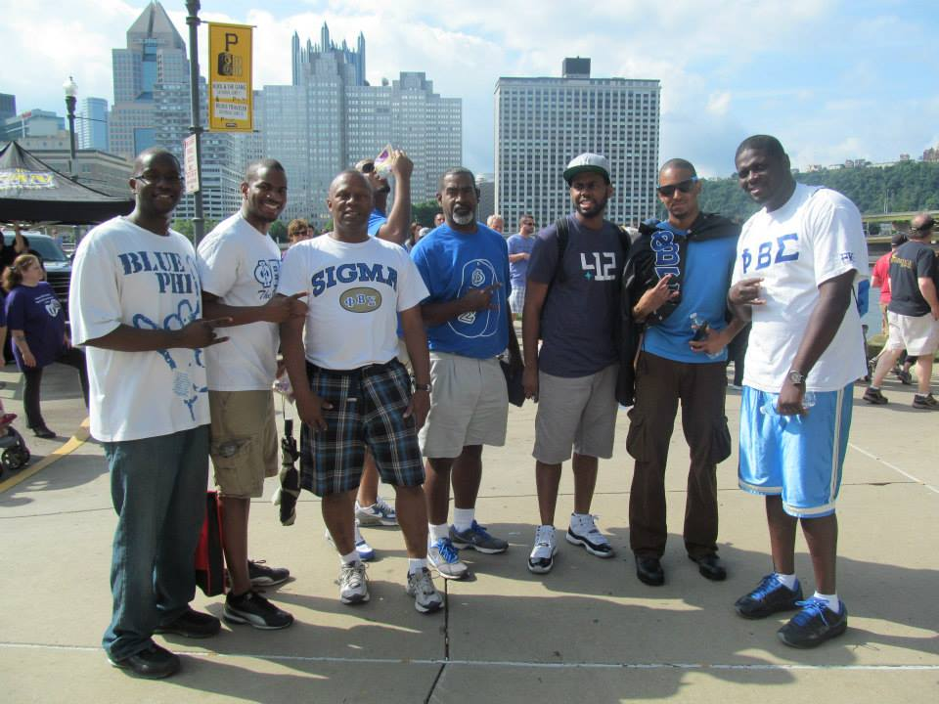
* Habitat for Humanity  
  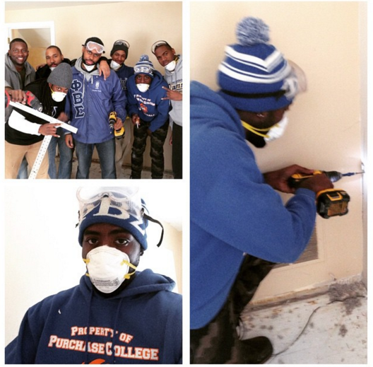
* Painting With A Twist  
  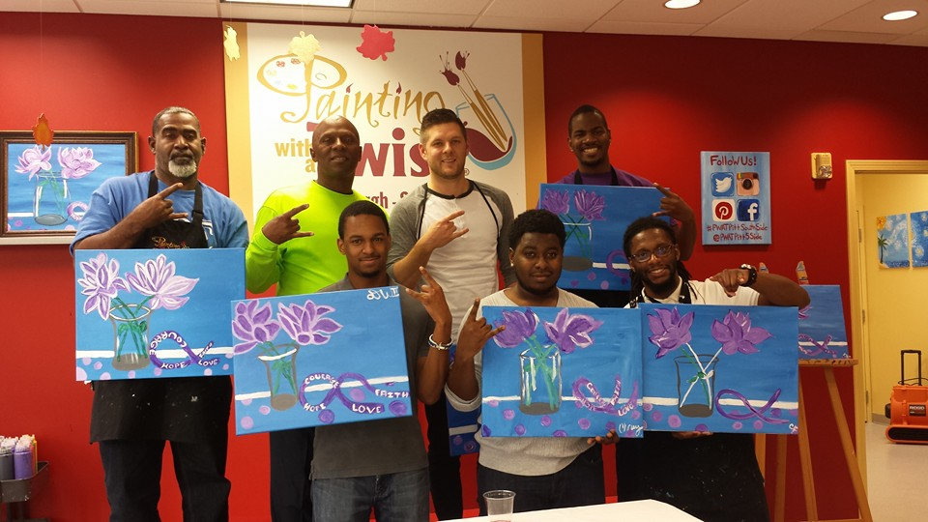
* Fairview Park  
  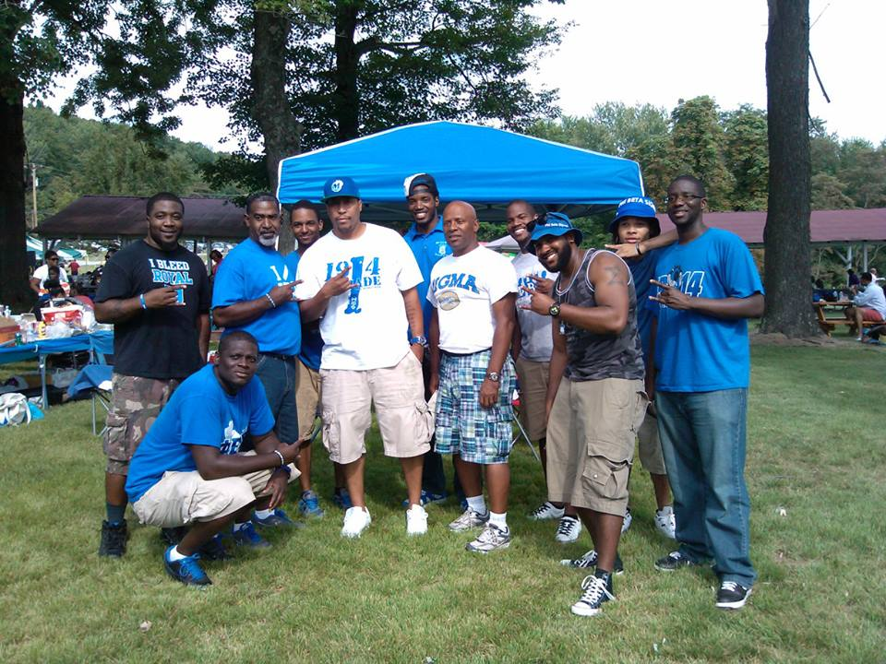  
  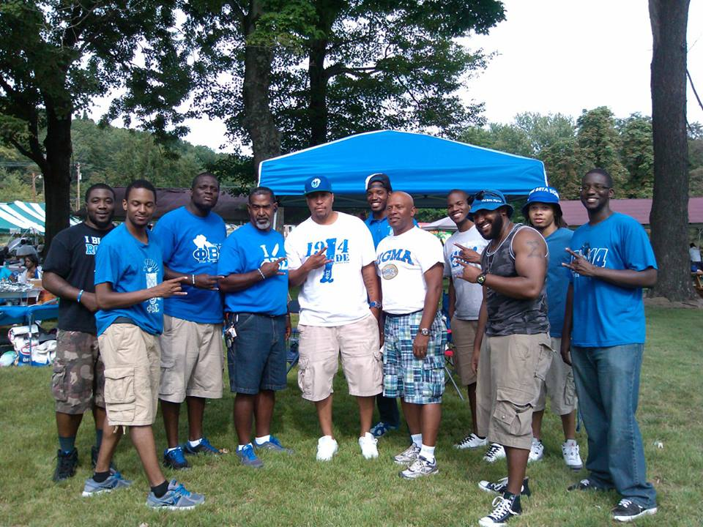  
  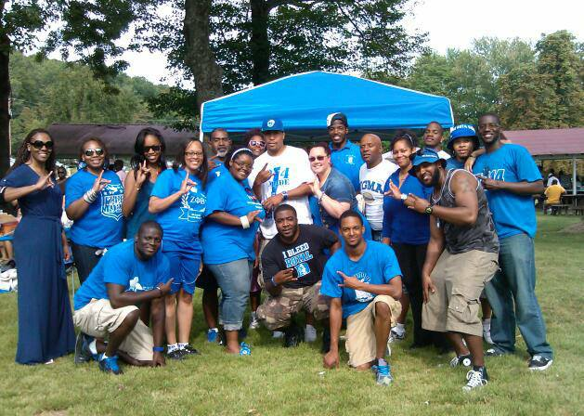

# Membership Growth and Retention

While the Chapter did asses the possibility of conducting Intake, the decision and will of the chapter was to prioritize bringing Brothers back into the fold thru Reclamation as well as making our presence as a Chapter as a whole (not just a few Brothers or advisors) seen by the Undergrads on a more consistent basis so they can begin to get into the mindset of Matriculating right into the Alumni Chapter after Graduation. The Chapter has decided to work towards tapping into these to existing resources to facilitate Growth, but we have not completely disregarded the idea of Intake and we were recently contacted by a few men who were interested in becoming Members of the Alumni Chapter and we will evaluate both the idea of the Chapter conducting Intake as well as the potential Candidates themselves and proceed in the way that is best for our Chapter.

# Chapter Operations

At the start of the year the Chapter’s primary goal was to obtain 501(c)(3) status for our Non-Profit, Blue Promise, which act as an umbrella for all Phi Beta Sigma and Sigma Beta Club Activities in Western Pennsylvania and in July 2015 we were successful in obtaining this status. After obtaining 501(c)(3) we then set out to identify what grant opportunities we could apply for, incorporating branding the Non-Profit, with our Chapter in the best way to remain in line with our Fraternity standards, but still provide enough visibility to show the IRS that the Non-Profit is being properly utilized.

Sigma Beta has been a program that the Chapter has wanted to get in for a long time and while Gamma Lambda Sigma is fortunate to have the State Sigma Beta Club Director in their Chapter, there still remain hurdles that the Chapter has yet to clear. The Chapter has identified what Brothers will serve as Advisors, Programs and Areas of Focus from the Rise and Thunder Curriculum they will be implementing and avenues for raising funds to help support a Sigma Beta Club, there is still issue with getting a reliable location to host to the Sigma Beta Club out of that would be feasible for Children to get to and from. The Chapter has also run into some issue when attempting to explain to schools, rec center, or church administration how the Sigma Beta Club works and that it isn’t a temporary mentoring club than can be rotated out after a few weeks to make way for another after school program.

The Chapter has begun to expand its list of annual programs up to Sigma’s Against Domestic Abuse, Fairview Park Community Day, March of Dime – March for Babies, and not Habitat for Humanity.

We have increased our communication with our undergraduate chapters so that Brothers in the Alumni Chapter are constantly aware of the quality events these Undergraduate Chapters are putting on, and so that the Undergrads are both aware of the resources and skills that the Alumni Brothers possess and would be willing to use to help their Chapter’s as well as news and opportunities from the State, Regional, and National Level.

The Chapter has had fruitful dialogs with 2 Universities that have dormant Chapters that we are looking to reactivate and we are keeping constant communication to let them know what we would require of any potential candidates and the chapter itself to be reactivated as well as ensuring that we comply with their current policy on fraternity and sorority life.

The departure of Brother Demetrius Tucker, who serves at the Western Pennsylvania Area Deputy Director, to North Carolina due to work relocation was unexpected and while that dealt and unexpected blow to the Chapter, we are sure that it will both provide a welcome addition and asset for his future Alumni Chapter in Charlotte as well as an opportunity for Brothers of the Gamma Lambda Sigma Chapter to step up and take on the responsibilities that Brother Tucker once held in the Chapter.

Thru our reclamation efforts we have started to bring some Brothers back into the fold but we have a long way to go. We are working on trying to get them back to doing the work of Sigma as well as addressing the issues that caused them to walk away in the 1st place. This is not an easy endeavor as the majority of the current chapter were not in Gamma Lambda Sigma when a lot of the older Brothers were so not only do we not understand why exactly they stopped being active but we also do not have the best preexisting relationships with them to get the dialog started. There is also the issue of these Brothers still wanting the support of Sigma or to do work in the name of Sigma and thus attempting to use the Fraternities name without approval. We are going out our way to try to inform Brothers that the way the Fraternity operates has changed and we can no longer just use our Organizations name whenever we want, even though they are still members, we have seen some promising signs that we will both be able to educate inactive Brother’s on the state of Sigma and bring some of them back into the fold as we see that the passion and fire for Sigma still burns brightly in them.

Lastly at the end of 2015 the Gamma Lambda Sigma Chapter elected new officers. We believe that these Brothers possess a combination of youth which should bring about fresh ideas, business acumen that they have acquired from their time serving as leaders of their undergraduate chapters and other organization, an understanding of fraternity protocols that they acquired from their numerous attendances at Fraternity Conferences and Conference Calls, as well as a proven and unwavering commitment to Sigma.

# Chapter Special Projects, Activities and Events

All Events, Projects, and Activities previously documented in PIA Reporting.